1.6 –Absolute Value Equations and Inequalities

Absolute Value: the distance a number, x, is from 0 on a number line (denoted by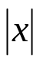)

Absolute Values
Find the absolute value for the following:
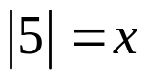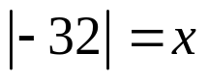

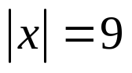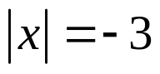

Solving an Absolute Value Equation
If 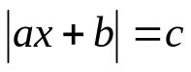, where c > 0, then:
- ax + b = c AND ax + b = - c

Example: Solve 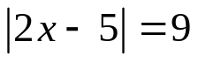

Solve for x.
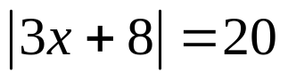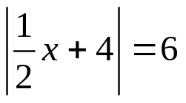

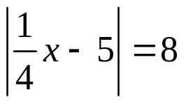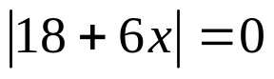
1.6–Absolute Value Eqns. and Inequalities (Day 2)

Absolute Value Inequalities;
The inequality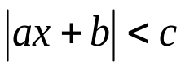, where c > 0, means that ax + b is between –c and c.
- If absolute value is Less THAN; “AND”

Therefore,
is equivalent to –c < ax + b < c

The inequality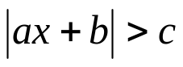, where c > 0, means that ax + b is beyond –c and c.
- If absolute value is GreatOR; “OR”

Therefore,
is equivalent to ax + b < -c or ax + b > c

< can be replaced by ≤ , and, > can be replaced by ≥

Graphing:
Use a number line

Examples:
Rewrite the absolute value inequality as a compound inequality
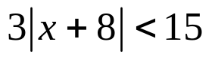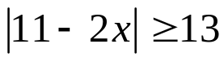
Solve 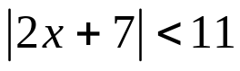, and then graph the solution

Solve 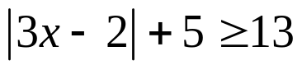, and then graph the solution

Physicians consider an adult’s normal body temperature to be within 1° F of 98.6° F, inclusive. Write an absolute value inequality that describes the range of normal body temperatures

You are a quality control inspector at a bowling pin company. A regulation pin must weigh between 50 ounces and 58 ounces, inclusive. Write an absolute value inequality describing the weights you should reject.
1.6 Extra Review
Steps to Solve an Absolute Value Equation/Inequality:
1) Add, Subtract, Multiply or Divide to get the Absolute Value by itself
2) Follow steps for solving either absolute value equations or inequalities
3) Remember < = AND and > = OR
4) Warning: Distance cannot be negative. 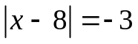 and 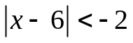 has no solution

Examples:
Solve each problem
1. 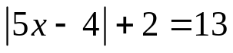 2. 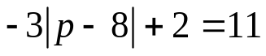

3. 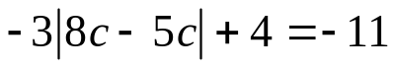 4. 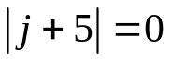

5. 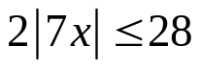 6. 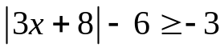

7. 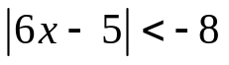 8. 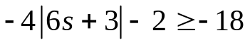

9. Some say that the perfect temperature for a hot tub is no more than 97 degrees F, plus or minus 1 degree. Write and solve an inequality describing the maximum and minimum temperatures for the perfect hot tub temperature.

10. A Thanksgiving turkey is ideally cooked when the stated temperature of the meat thermometer differs from the necessary temperature of 180 degrees F by no more than 5 degrees. Write and solve an equation to find the minimum and maximum temperature of a cooked turkey.

